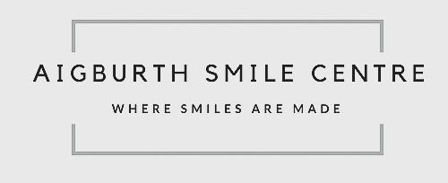

**Oral Surgery Referral Form**

Patient details:

Surname: First name:

Date of Birth:

Address:

Contact Number(s):

Practice Details:

Referring practitioner:

GDC number:

Practice Address:

Phone:

In your opinion is the referral: Shape Routine Shape Urgent

If urgent, please give further details:

Clinical details/Reason for referral:

*(please turn over for dental charting, where relevant)*

Shape Frenectomy

Shape Simple extractions

Shape Complex extractions

Shape Surgical extraction

Shape Tooth exposure

Shape Bonding of tooth

Shape Apicectomy

Medical history:

*(please include all medical conditions, medications and allergies)*

Imaging:

Shape Enclosed Shape Available elsewhere (give details)

*(Referrals will not be accepted without relevant imaging)*

Please indicate on the chart below which teeth are for extraction, or that require treatment:

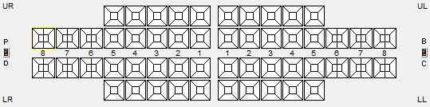

Also please note any pending restorative work planned.

Other relevant information:

*Referrals are accepted by post and email:*

*Aigburth Smile Centre, 99 Aigburth Road, Aigburth, Liverpool, L17 4JU.*

*info@aigburthsmilecentre.co.uk*